**INTELIHELMET**

**The Smart Safety Helmet**

|  |  |
| --- | --- |
| Registration No. | Name |
| IT23525590 | K.K.V.T Katugampala |
| IT23223394 | B.S.K.J Perera |
| IT23161160 | S.A.K.S Sathurusinghe |
| IT23225510 | K.W.R.L.V Ranasinghe |

Degree of Bachelor of Science

Department of Information Technology

Sri Lanka Institute of Information Technology

Sri Lanka

August 2023

**DECLARATION**

“We declare that this is our own work, and this proposal does not incorporate without acknowledgement any material previously submitted for a degree or Diploma in any other University or institute of higher learning and to the best of our knowledge and belief it does not contain any material previously published or written by another person except where the acknowledgement is made in the text.

Project Team ID: CT/2023/08

Signature: 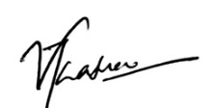 Date: 1\9\2023

Date: 1\9\2023

Signature: 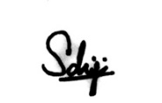 Date: 1\9\2023

Date: 1\9\2023

The above candidate is carrying out Computational Thinking Project under my supervision.

Signature of the supervisor: Date:

**ABSTRACT**

The mining industry is an industry with constant value from the past to the present day. It allows for the extraction and finding of subsurface resources such as iron, gold, coal, and diamond. The economy of the country greatly depends on the mining sector. Mostly miners have to dig underground. This involves various risk factors which affects the health of miners. Harmful events tend to occur in the mining industry that can lead to severe injury or be fatal. It is a very dangerous process, and the safety of the miners must always be considered. A necessary part of the mining industry is safety. Nowadays, mining accidents claim the lives of hundreds of miners every year, mostly those engaged in underground coal mining. The main reason for mining accidents is collapse.  The collapsing accidents of coal mining are not always that  much danger. Immediate rescue helped a lot of worker’s life.We feel that there is a need for a more safety helmet than the current safety helmet. Also, during problems like fire, rock fall, explosion conventional wired communication system is unreliable, so we require a wireless sensor network. A mining helmet could be modified to increase the safety of miner by adding technology to the helmet. The basic objectives of our efforts are to check and confirm the miner’s health conditions, to free the miner from unsafe environmental conditions and to educate them about it, and to strengthen the connection between the miner and the supervisor. For that, the information is sent to the control room through a wireless network. This secures the life of miners in mining industries. This is a cost effective, real time surveillance system with portability and accuracy that can avoid safety problems by early warning

***Keywords:*** *Mining Industry, Safety Helmet, Communication, Sensors, Mining Accidents, Comfortable, Safety, Wireless Sensor Network*

**TABLE OF CONTENTS**

**LIST OF TABLES** 5

**LIST OF FIGURES** 6

**LIST OF ABBRIEVIATIONS** 7

**INTRODUCTION** 8

**I.** **Problem Addressed** 8

**II.** **Background context** 10

**OBJECTIVES** 12

**I.** **Main Objective** 12

**II.** **Sub Objectives** 12

**BODAY OF THE REPORT** 13

**I.** **Literature** 13

**II.** **Methodology** 15

**TESTING AND EVALUATION** 26

**I.** **Testing** 26

**II.** **Evaluation** 28

**PERSONAL AND FACILITIES** 29

**BUDGET** 30

**REFERENCES** 31

**GLOSSARY** 32

**APPENDICES** 33

# **LIST OF TABLES**

Table 1: mpu6050 pin out 18

Table 2: Budget 30

# **LIST OF FIGURES**

Figure 1: Diagram for the flow of Kansei Engineering 9

Figure 2: major mining disasters in 2022 10

Figure 3: research found a shortage of smart helmet devices on the market 14

Figure 4: MQ-9 gas sensor 15

Figure 5: code that used to read the analog value from the mq-9 16

Figure 6: MAX30102 sensor 16

Figure 7: libraries that used to program the heart sensor 16

Figure 8: Connection diagram of MAX30102 17

Figure 9: MPU6050 module 17

Figure 10: Jarzebski’s MPU6050 library from GitHub 18

Figure 11: diagram of mpu6050 with Arduino 18

Figure 12: ESP8266 Wi-Fi module 18

Figure 13: ESP8266 and Software Serial libraries 19

Figure 14: connection diagram of esp8266 with Arduino 19

Figure 15: brief diagram of Intellihelmet 20

Figure 16: DS18B20 module 20

Figure 17: Vibration motor module 21

Figure 18: Arduino Uno R3 board 22

Figure 19: Flow Chart of the Arduino Code 23

Figure 20: Circuit Diagram 24

Figure 21: Helmet Design 25

Figure 22: circuit mounts 25

# **INTRODUCTION**

## **Problem Addressed**

The mining industry is one of the most prominent earning sources of many different countries since the growth of the mining industries. Sri Lanka is a land with many natural reserves of mineral and valuable rocks. Underground mining, surface mining, high wall mining, quarrying are some of the mining techniques used in the country. It’s possible that miners are unaware of environmental factors like pressure changes, mine ventilations, temperature changes and other. Each year, mining accidents claimed the lives of thousands of miners, particularly those engaged in hard rock and coal mining. One of the major causes of the majority of these incidents is collapsing mining stops.In an era of rapid technological advancements, ensuring the safety and well-being of workers in the mining industry has become a priority. For the mine workers who are currently tired of many such problems, we introduce the project for their convenience: **INTELIHELMET** – The Smart Safety Helmet.

A mining helmet could be modified to increase the safety of miner by adding technology to the helmet. Several systems are being developed for this purpose by using various technologies in different countries. The design of the smart helmet we propose is done basically using Kansei Engineering principles. Kansei Engineering was founded at Hiroshima University 35 years ago and is a strategy that converts the customer psychological feelings into design elements (Kalansooriya, 2016). Also, it can be defined as a branch of Ergonomics that focuses on developing new products based on the demands of the consumer and, therefore, as a consumer-oriented technology (Nagamachi, 1996). 107 The figure 1 depicts the flow of Kansei Engineering that involves the conversion of human emotions into design specifications.

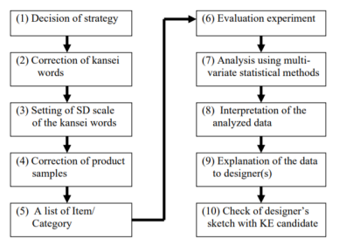

Figure 1: Diagram for the flow of Kansei Engineering

Our smart safety helmet project provides a wide range of benefits for the well-being of miners. Modern sensors as well as handling constantly updated data files are revolutionizing the mining industry in a wide range of ways and answering the problems of miners.

**The Challenge**

To avoid mining accidents, all mining industries follow some basic rules and precautions. Despite existing safety practices, many miners still face life-threatening conditions. But still there has not been enough reduction in these accidents. The main challenge is to find solutions for this without the large labor exchange associated with the new technology that is more advanced than the existing security systems.

**Our Vision**

Our Vision is to introduce a smart safety helmet using the latest technology to ensure the safety and health of the miner. In addition, this is intended to create a constantly updated data exchange between the miner and the supervisor, improving the relationship between the miner and the supervisor.

## **Background context**

The mining sector has many facets and involves intricate processes carried out below, in tunnels, etc. This comprises a few risk variables that have an impact on miners' health. It often be hazardous, with the threat of a fire, flood, explosion, collapse, or other accidents affecting a large number of people simultaneously. Over 3.3 billion tons of metals are produced each year globally as the mining sector offers raw materials, minerals, and metals essential to the economy, and the global mining sector is showing no signs of slowing down.

According to UK Government research, most demand forecasts predict a rise in metal use in the coming decades, including in renewable energy generation, electric cars and batteries. With this increase in demand and production, key changes to the global mining industry could be necessary to improve its safety performance, from increased government oversight to labour reform, to ensure workers are safe and accidents are prevented.

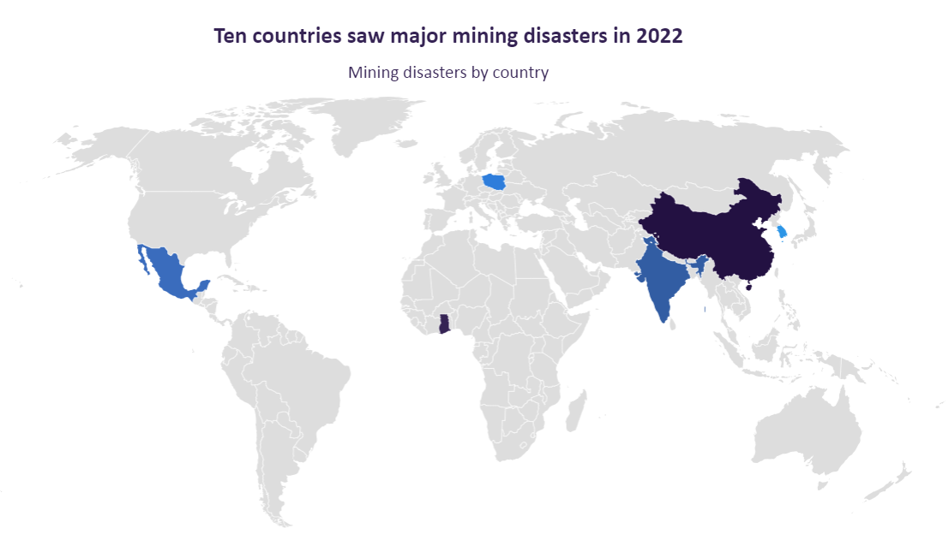

Figure 2: major mining disasters in 2022

Human error, unsafe behavior, unsafe acts, lack of safety training, lack of safety education, inexperienced workers, leadership behavior of supervisors, organizational deficiencies, mechanical failure, geological factors, poor workplace environment, poor safety are the main causes of mine accidents.

Mexico - A coal mine collapsed in the Mexican municipality of Sabinas, causing a tunnel to flood and confine the employees. On 3 August 2022, workers were caught inside a coal mine near Sabinas, 70 miles from Eagle Pass on the US-Mexico border, when it collapsed and trapped them.

Poland - A coal mine in southern Poland killed five and trapped seven people, Prime Minister Mateusz Jakub Morawiecki told reporters on 20 April 2022, in a tragedy triggered by an early-morning explosion.

China - On 23 July 2022, ten people were killed, and seven were injured, when a mine in northwest China collapsed.

India - According to local authorities, five people were confirmed dead in February 2022 when a rubbish pile fell on residents attempting to extract coal from an abandoned open-cast mine owned by state-run Coal India in the eastern state of Jharkhand.

South Korea - Officials announced on 4 November 2022 that two South Korean miners trapped inside a collapsed zinc mine in the country's north-eastern county of Bonghwa crawled out nine days later.

Ghana - A mining disaster in Western Ghana killed 17 and wounded hundreds, prompting criticism of the country's industry's failed safety rules.

Gas accumulation in goaf, coal and gas outburst, insufficient air volume of local ventilator, and other factors lead to the possibility of local gas accumulation. Electric sparks, illegal smoking, and illegal blasting are highly likely to lead to ignition. It can be seen from the results of the maximum cause chain analysis. These factors together with the weak safety awareness of employees and enterprise safety management confusion formed the key cause chain of gas explosion accidents. Therefore, coal mine enterprises should strictly implement the safety work guidelines, pay attention to underground ventilation management, fulfill the responsibility of safety management, implement daily safety inspection work, and put an end to employees’ illegal command and illegal operation. Therefore, the detection of unnecessary gases is the most important thing in the mining industry.

# **OBJECTIVES**

## **Main Objective**

Developing a smart safety helmet for mineworkers that enhance safety and communication in hazardous underground environments.

## **Sub Objectives**

1. Monitoring hazardous environmental conditions in the mine and providing solutions to them.

* Conducting a general quality check on the environmental conditions of the mine.
* Inserting a gas sensor and a thermal sensor to the smart helmet.
* Making the miner aware of dangerous situations.

1. Provide necessary notifications to the supervisor in case of emergencies.

* Creating a website to enhance the relationship between miner and supervisor.
* Notifying the supervisor through the website as soon as an emergency occurs.
* Operating a database of miners’ information that is constantly updated.

1. Checking the miners’ health status and notifying the supervisor.

* Installing a heart sensor on the helmet to know about the miners’ health.
* Informing the miner about the health condition as soon as it becomes abnormal.
* Sending a summary of its data to the supervisor’s website.

1. Designing a helmet that is comfortable and has high durability.

* Fixing all components to the helmet so that the miner is not obstructed.
* Attaching a gyroscope to the helmet to further ensure the convenience of miners.

# **BODAY OF THE REPORT**

## **Literature**

The development of a smart helmet includes several features, including two-way communication, the detection of hazardous gases, notification if the helmet is removed, collision (miners are struck by an object), a panic button for emergency situations, and continuous monitoring of environmental conditions such as temperature and pressure in the mining industry. GPS is also included to track the miner's location. The miners' access to oxygen is provided inside the helmet by the solenoid valve of the oxygen cylinder once the presence of dangerous gas has been identified. For the miners' protection, panic switches are supplied, and they are used to warn the control room in case of emergencies.

The mining industry mostly uses cables and wired networks to communicate with the ground center. In mines, if an accident happens, the sensors and cables were usually damaged fatally by the explosion, and so we couldn’t provide information for rescue search and detection events. We used wireless sensor network to communicate at times of such accidents and to detect several activities like helmet removal, collision detection and long-term posture detection. And an IoT-based smart helmet's design and development for real-time monitoring of worker health and safety in underground mines are develop in this system.

By using our helmet, we can minimize the death toll in the mining industry. This is because by collecting the data that comes into the control room, we can immediately support miners in the event of danger. Many of these helmets consist of two parts.

• Transmitter section: This section is attached to the miner's helmet.

• Receive section: This section is mounted outside the control room.

Sri Lankan miners only wear helmets at the mine. It is known that many accidents occur in the mine if you cannot communicate with your mobile phone in the mine without using a smart helmet. This is a real problem facing the mining industry. It is important to minimize accidents in the mining industry and save the lives of miners. Communication in underground mines is a very important issue.

Product research found a shortage of smart helmet devices on the market to assist in communication inside the mine and outside the control room,

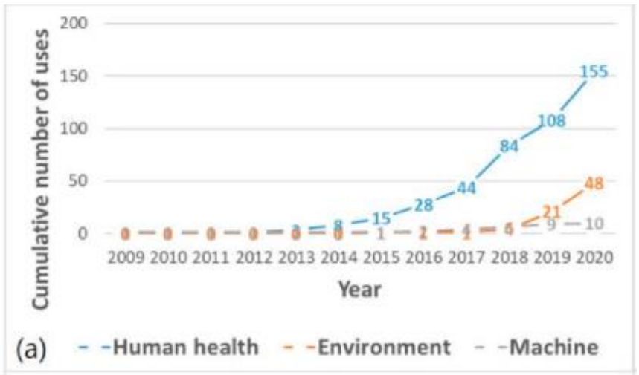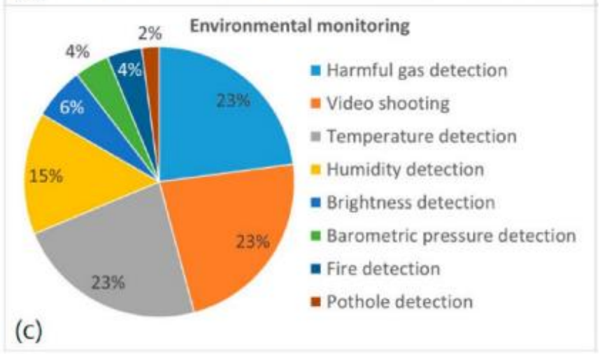

Figure 3: research found a shortage of smart helmet devices on the market

## **Methodology**

In the making of **INTELLIHELMET** we focus on two main problems according to our research. Which are,

1. Keeping the mine workers’ safety and comfortability.
2. Facilitate monitoring for supervisor.

To achieve these two targets, we bring a solution for both ones with two major pathways. Those are,

1. Smart safety helmet for mine workers’ which called Intellihelmet.
2. Supervisors’ website for monitoring and managing workers.

With these solutions, the goals we are aiming to achieve are,

* Support to reduce the deaths happens in mining industry.
* To improve the communication between miners and the outside world.
* Develop a device that is beneficial to most of the miners in Sri Lanka.

To fulfill those goals and objectives we designed a Smart Helmet with following features,

1. **Detecting Harmful Gases,**

Using MQ-9 gas sensor we can detect harmful gases such as carbon monoxide (CO), methene (CH4) and propane (C3H8) with more accuracy than other gas sensors like MQ-3, MQ- 4 and MQ-7.

When sensor data goes beyond its analog value 150 it’ll indicate the presence of harmful gas to the supervisor, and it’ll go far more than 400 indicator turns into to an emergency alert. Through website to the supervisor and through vibration motor to the worker it will give warnings to leave the location immediately.

Figure 4: MQ-9 gas sensor

This code reads the analog value from the mq-9 gas sensor connected to pin A0 of the Arduino uno board and prints it to the serial monitor (Printing on the serial monitor is only for our understanding).

Figure 5: code that used to read the analog value from the mq-9

1. **Heart Rate Monitoring,**

Through supervisor’s website he can monitor the mine worker’s real time heart rate and blood oxygen level. We use MAX30102 oximeter heart rate beat pulse sensor to measure the data from worker’s body. The main reasons to select this sensor are it can be used to get bpm and spo2 both and its low power consumption (1.8v-3.3v).

With this feature, supervisor can identify workers stress level from spo2 data and another health issues from his heart rate. It will help to prevent any emergency health conditions before they happen.

Figure 6: MAX30102 sensor

We use these libraries to program the heart rate sensor.

Figure 7: libraries that used to program the heart sensor

Figure 8: Connection diagram of MAX30102

To communicate with the sensor, we use A4, A5 and D2 pin outs in Arduino uno board.

1. **Long Term Posture Detection,**

To avoid the muscle pains like back pain and lower neck pain, we use this feature to give a feedback to the worker to change his posture. To do this we use MPU6050 triple axis analog accelerometer gyroscope module.

Figure 9: MPU6050 module

Using this module, we can also calculate and record how many times helmet was removed, and how many collisions got by helmet. Measuring 40-minute time period of worker head position if it stays same for 40 minutes, feedback will be given by vibration motor to the worker.

Here, we will be using Korneliusz Jarzebski’s MPU6050 library from GitHub.

[(Download Here)](https://github.com/jarzebski/Arduino-MPU6050/archive/master.zip)

Figure 10: Jarzebski’s MPU6050 library from GitHub

Figure 11: diagram of mpu6050 with Arduino

|  |  |
| --- | --- |
| MPU6050 | Arduino uno |
| SCL | A5 pin |
| SDA | A4 pin |
| ILT | Pin 2 |

Table 1: mpu6050 pin out

1. **Real Time Monitoring,**

Through supervisor’s website he can monitor all the sensor data taken from worker’s helmet.

To establish the connection between them we use an ESP8266 Wi-Fi module.

Figure 12: ESP8266 Wi-Fi module

But this Wi-Fi module can only be used in small mines only. If you need this to use in big mines like the graphite mine which in Bogala, Wi-Fi range extenders must be used in every tunnel, because through graphite, any radio signal won’t be passed.

When using this Wi-Fi module, we use ESP8266 and Software Serial libraries those are showed in right.

Figure 13: ESP8266 and Software Serial libraries

Figure 14: connection diagram of esp8266 with Arduino

Furthermore, we built a website for supervisor to monitor these stats. We use Figma for the developing site UI and front end. Also, we built site back end using php. Using this website supervisor can monitor workers even from his home. And we include every worker data base to that web site, so it will make more easier for supervisor to calculate their working hours etc.

This small diagram of our project will help you to understand more about monitoring,

Figure 15: brief diagram of Intellihelmet

In addition to these features, we include LDR for the helmet’s light, which can control the brightness of light and save the helmet’s battery. Also, we included 1200 mAh li-ion battery with wireless charging. It will make more easier to use the helmet for workers and also it will help the durability of helmet because there’ll be no in or out ports.

And, natural disaster like earthquake, when mine was collapsed, helmets will go to emergency mode, and it will only send workers heart rate data to save the battery power until rescue teams rescue workers. That feature will also help to count the how many alive under the mine when it collapsed. So, rescuers can be more specific in their mission.

Furthermore, we used temperature sensor module to measure the body temperature of every worker. It can also monitor real time through web site. Using its measurements supervisor can identify fevers and spreading of viruses can also noticed by analyzing every worker’s body temperature. We use DS18B20 temperature module for it, which can measure temperature between -55 °C ~ +125 °C (-67°F~+257°F) with deviation ±2°C ,-10°C~+85°C deviation ±0.5°C.

Figure 16: DS18B20 module

**Vibration Feedback,**

The only output device we use except the web site is, the vibration motor module. Using that we give different kind of alerts to the worker. We use specific patters for every specific alert.

As our motor module we use PWM 10x27 vibration motor which comes with its motor controller drive. So, we don’t have to separate motor driver for this module.

We use signal patterns like morse signal system for different alerts.

Figure 17: Vibration motor module

**.** : Short Vibration **-** : Long Vibration

Emergency Alert : **-----------------------**

Change the posture : **…………..**

Low battery : **.. .. .. .. ..**

Abnormal BPM or Temperature : **- - - - - -**

Harmful gases low level : **.- .- .-**

*You can also create your own custom patterns if you want. They are some examples only.

**Our Development Board,**

We use Arduino Uno R3 board as our development board. The main reason to select this board is the size of it comparing to other development boards such as Arduino mega, Rasbery Pi.

If we use Arduino mega board we can add more features like real time tracking, walkie talkie etc. But there’s not much space available inside a workers helmet. So we decided to go with Arduino uno.

Figure 18: Arduino Uno R3 board

This board based on the ATmega328P. It has 14 digital input/output pins (of which 6 can be used as PWM outputs), 6 analog inputs, a 16 MHz ceramic resonator, a USB connection, a power jack, an ICSP header and a reset button. [It contains everything needed to support the microcontroller; simply connect it to a computer with a USB cable or power it with an AC-to-DC adapter or battery to get started](https://docs.arduino.cc/hardware/uno-rev3/). [The UNO is the most used and documented board of the whole Arduino family](https://docs.arduino.cc/hardware/uno-rev3/). [You can tinker with your UNO without worrying too much about doing something wrong, worst case scenario you can replace the chip for low cost and start over again](https://docs.arduino.cc/hardware/uno-rev3/).

Low cost is another major advantage of this board. It’ll reduce the maintenance costs half. And also, it’s parts can be found any local shop in Sri Lanka with very affordable prices.

**Flow Chart of the Arduino Code,**

Figure 19: Flow Chart of the Arduino Code

This is the flow chart of our whole project. There are all the features and functions I mentioned above. We write out Arduino code according to this flow chart.

**Circuit Diagram,**

Figure 20: Circuit Diagram

*This is only a diagram; components will be placed differently when mounting to the helmet.

**Helmet Design,**

Another main goal is giving comfortable helmet to the workers. So achieve that goal design of the helmet is really important part.

We use normal construction helmet as our base model and, we modify it according to our needs.

Figure 21: Helmet Design

To attach our components to this helmet we design custom plastic mounts using Solid works and 3d print them. When doing it we use most strong and lightest materials which can be found in local market like carbon fiber.

Also, some sensors like heart rate sensor will be placed in a strap which we added by ourselves. Vibration motor will be placed other side of the same strap.

And keep this helmet’s weight light, all components we chose are the lightest ones can be found in local market. Best example is our development board, instead of using Arduino mega board we used Arduino Uno board to keep the weight lightly.

Some of the circuit mounts we decided to 3d print are shown below,

Figure 22: circuit mounts

# **TESTING AND EVALUATION**

Ensuring the well-being of mining workers, **INTELLIHELMET** will undergo a comprehensive testing and evaluation processes, to validate the effectiveness, reliability, durability in real-world conditions. This will guarantee that helmet meets the industry standards.

## 

## **Testing**

**Impact resistance testing**

Impact resistance test will verify the helmet's ability to withstand falling objects or collisions and absorb impact forces. Testing methods of drop test, shock absorption test, puncture test and angular impact test will be used. Drop test includes releasing a weighted item from specific height and shock absorption test is to check the helmet’s ability to handle different levels of impact energy, using a device and delivering a controlled impact force. To check helmet’s defense against sharp objects, puncture test method will be used, and angular impact test will check the helmet’s ability to handle impact forces in many angles.

**Functional testing**

This test will examine helmet’s comfort, practicality and usability. The phases of confirming fit, adjustability, stability and movement will be verified during functional testing. Feedback of miners of various head sizes will be used as the testing method of functional testing.

**Heat and flame resistance testing**

Heat and flame resistance test is to review the reliable protection for miners in hazardous situations, according to industry standard. There will be various important testing methods.

Flame resistance test will be done revealing the helmet to flames for designed time and check the flame spread rate. Further helmet will be exposed to radiant heat, hot air, toxic gasses, excessive smokes and molten metals. It is crucial to ensure that the helmet can withdraw high temperatures and it will be done by using oven-like environment. The helmet will also undergo repeated temperature changes to ensure its effectiveness when exposed to thermal stress. The materials used also will be tested individually under combustion test in heat and flame resistance testing.

**Electrical insulation testing**

Controlling electrical conditions to protect miners from electrical hazards we will undergo an electrical insulation test. Testing methods will be surface resistance test, dielectric strength test, leakage current test, flashover test and materials compatibility test.

Surface resistance test will ensure that the material of the helmet will prevent electrical current from flowing across the surface, reducing electrical shocks. By undergoing through a dielectric strength test, the highest voltage the helmet’s insulation can handle without experiencing electrical failure or breakdown will be determined. Leakage current test’s purpose is to confirm that the helmet effectively blocks significant electrical current from reaching the miner. Flashover test involves exposing the helmet to a sudden increase in voltage and materials compatibility test includes checking metal parts (wires/metal pieces) won’t compromise the insulation of the helmet.

**Durability testing**

Durability testing ensure the longevity of the helmet despite of the hazard environmental conditions and continue the high quality of the helmet over time.

## **Evaluation**

**Data analysis**

We will analyze the data we will have collected from the testing phases mentioned above. The purpose of the data analysis is to identify patterns, trends and what we have to improve more. Data analysis is a statistical analysis containing measurements and also feedback.

**Comparative study**

A comparative study is essential to understand the users how intellihelmet stands out from existing models and to understand the benefits. We will measure our helmet’s performance against other models in the industry.

**Worker feedback**

To check the satisfaction of the miners of the intellihelmet, we will gather information through surveys and interviews. This will help us to capture the miners’ experience with intellihelmet in real world conditions.

**Iterative design refinement**

In iterative design refinement, we will modify the helmet’s materials or structure based on miners’ feedback, comparative study and our data analysis.

**Expert review**

The experts in the field will give us an unbiased review on our intellihelmet after going through every detail of the project and this will validate the suitability of intellihelmet for miners.

In this evolution process we examine both aspects of how intellihelmet meets the industry standards and useful for the practical needs of mine workers.

# **PERSONAL AND FACILITIES**

**Arduino code and circuit soldering**

Kaveen will be focusing on writing Arduino code that control smart features of the helmet including sensors. Additionally he will do the soldering equipment to the circuit board. He will use resources as Arduino development kit and soldering equipment.

**Designing and mounting circuits to the helmet**

Venuja is responsible on physical integration of electronic components to the helmet. He will make sure to add the components in a safe, well-fitting and comfortable way to the helmet. He will use SolidWorks and 3D technology as resources.

**Designing the website**

Vinuki and Sahaji will design and maintain the website using web designing languages like html, css, php. The website will include essential information as air quality, body temperature, neck posture, BPM. The website will be easily navigable and captivating. Graphic designing tools and hosting services will be the resources used. More specifically, the front end of the website will be developed by Sahaji and the back end by Vinkui.

The facilities includes a workplace with all essential tools for all members’ tasks mentioned above. There will also be a testing area to check helmet’s effectiveness.

# **BUDGET**

|  |  |  |  |  |
| --- | --- | --- | --- | --- |
| No | Item | Unit price  (Rs) | Quantity | Total Price  (Rs) |
| 1  2  3  4  5  6  7  8  9  10  11  12 | Arduino Uno R3 Board  Vibration Motor 5VDC PWM 1027 10x27  MPU-6050 Triple Axis Analog Accelerometer Gyroscope  DS18B20 Temperature Sensor  ESP8266 ESP-01S Serial WIFI Module  MQ9 LPG CH4 CO Carbon Monoxide Gas Sensor  Max30102 Oximeter Heart Rate Beat Pulse Sensor 1.8-3.3V  Jumper wire male-to-male(1x40-pin)  Short Jumper wire male-to-female(1x40)  Helmet  Wireless Charging Module  3.7V 1500mAh li-ion Battery | 3000  280  560  380  450  550  600  200  170  1600  3290  680 | 1  1  1  1  1  1  1  1  1  1  1  1 | 3000  280  560  380  450  550  600  200  170  1600  3290  680 |
|  |  |  | Total = | 11760 |

Table 2: Budget

# **REFERENCES**

# **APPENDICES**

**Technical specifications**

Materials

* Helmet shell- Acrylonitrile butadiene styrene (ABS)
* Cradle - PE/ textile
* Sweatband – Sponge
* Chin strap – Textile

Weight

* 420g

Size

* Helmet fitting size – (45-61)cm
* Sweatband - (L)25cm x (W) 4cm
* Chin strap – 1.6cm (W)

Dimension

* (L) 29.5cm X (W) 22.5cm X (H) 16cm

**User manual**

**Safety standards and regulations**

**Mine Safety and Health Administration (MSHA)**

* Title 30 Code of Federal Regulations (CFR) Parts 46, 47, 48, and 75

These regulations cover safety training, hazardous conditions, and safety standards specific to mining operations.

**Occupational Safety and Health Administration (OSHA)**

* Title 29 Code of Federal Regulations (CFR) Part 1910

This part includes general industry standards applicable to workplaces, including mining operations.

* Title 29 Code of Federal Regulations (CFR) Part 1926